

**Name – Tapas Mazumdar ID – 2018A8B40427P**

**Analog Electronics Lab #5 – Study of Instrumentation Amplifier using LM741**

**Objectives**

To study the Instrumentation Amplifier using op-amp LM741 and find out

1. Value of resistance (Rf) for DC null point,
2. Common mode gain (Acm) for the instrumentation amplifier,
3. Differential mode gain (Adm) for the instrumentation amplifier, and find
   1. the common mode rejection ratio (CMRR) for the instrumentation amplifier,
   2. compare the results from simulation with the theoretical values of the quantities.

Also, draw schematic for each case.

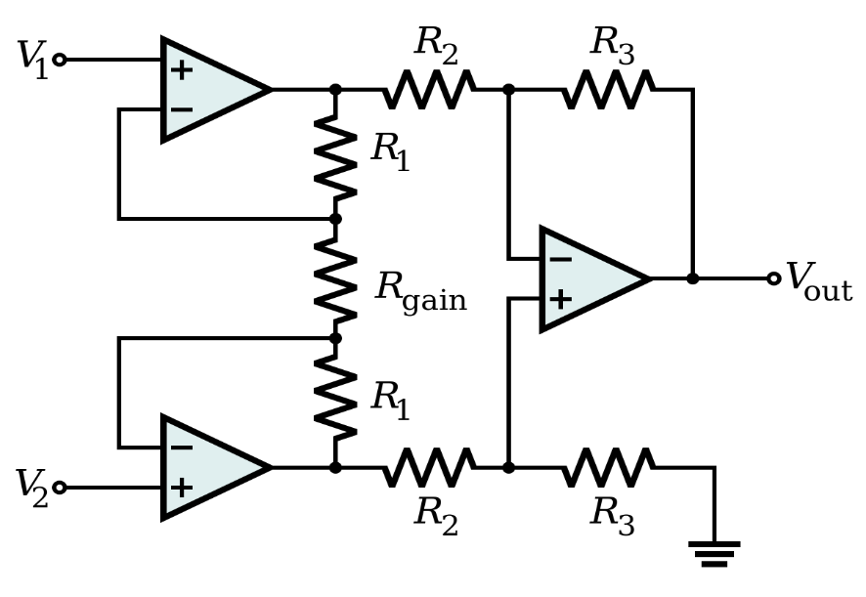

**Instrumentation Amplifier**

An **instrumentation amplifier** is a type of differential amplifier that has been outfitted with input buffer amplifiers, which eliminate the need for input impedance matching and thus make the amplifier particularly suitable for use in measurement and test equipment.

Additional characteristics include **very low DC offset, low drift, low noise, very high open-loop gain, very high common-mode rejection ratio**, and **very high input impedances**. Instrumentation amplifiers are used where great accuracy and stability of the circuit both short and long-term are required.

A

dm

=

Vout

V2−V1

= (1 +

Rgain

2R1 ) ⋅ R3

R2

**DC Null Point**

Schematic and results from AC analysis

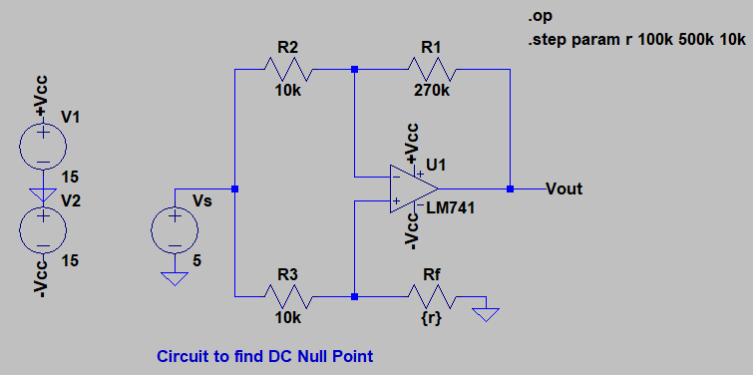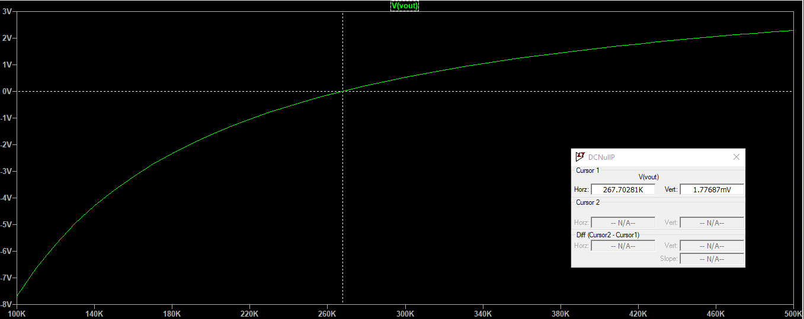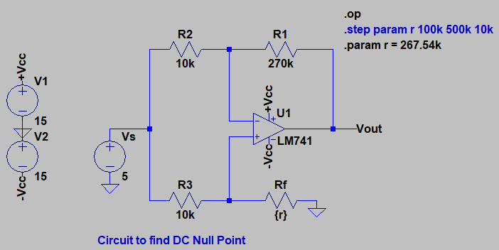

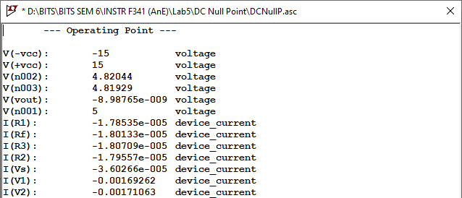

**Results**

The value of resistance Rf at DC null point (Vout = -9 nV ≈ 0 V) comes out to be approximately **267.54 kΩ**.

**Common mode Gain (Acm)**

Schematic and results from AC analysis

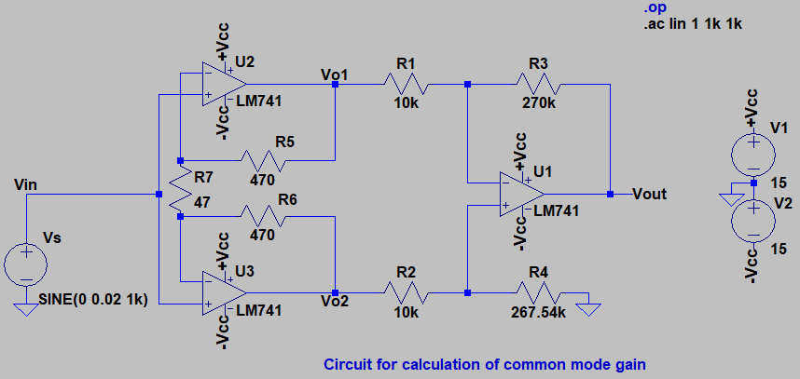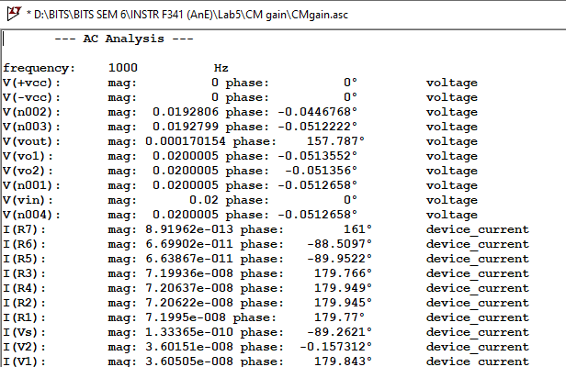

**Results**

* The value of common mode gain from simulation comes out to be **Acm = V(vout)/V(vin) = 0.000170154/0.02 = 8.5077 mV/V = -41.404 dB**.

•

The theoretical value of common mode gain should be **A =** − 𝐕 + (𝟏 + 𝐑𝟑) (

𝐑

𝟑

𝐑𝟒

**cm**

𝐑

) 𝐕

𝟏

𝐨𝟏

𝐑 𝐑 +𝐑

𝟏 𝟐 𝟒

𝐨𝟐

**= -(270k/10k) × 0.0200005 + (1+(270k/10k)) × (267.54k/(10k+267.54k)) × 0.0200005**

**= -0.5400135 + 0.539836 = -0.0001773 V/V = -75.026 dB**.

**Differential mode Gain (Adm)**

Schematic and results from AC analysis

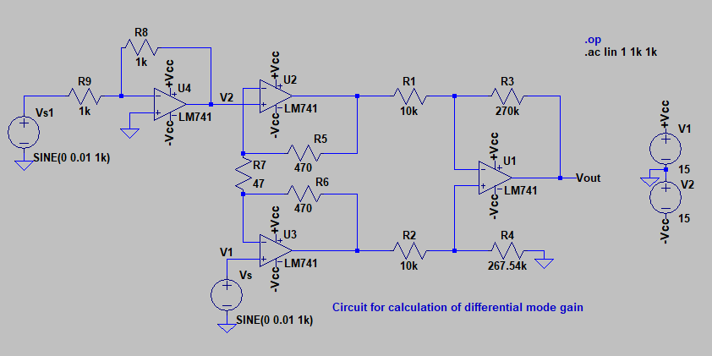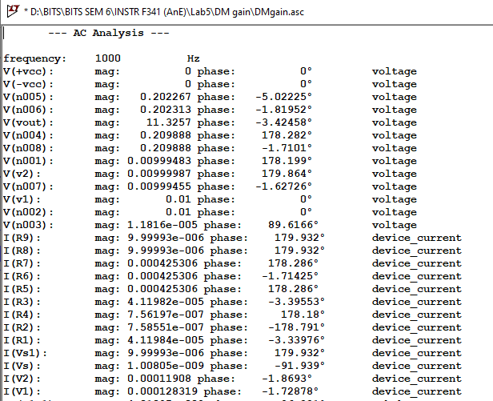

**Results**

* The value of differential mode gain from simulation comes out to be **Adm = V(vout)/(V(v1) - V(v2)) = 11.3257/0.02 = 566.285 V/V = 55.061 dB.**

•

The theoretical value of differential mode gain should be **A =** (1 + 2R5) ⋅ R3 **= 567 V/V = 55.07 dB.**

**dm**

R

7

R

1

**Calculation of CMRR**

The simulated value of common mode rejection ratio (CMRR) is

**CMRR =** 𝑨𝒅𝒎 **=**

𝟓𝟔𝟔.𝟐𝟖𝟓

𝑨𝒄𝒎 𝟎.𝟎𝟎𝟖𝟓𝟎𝟕𝟕

**= 66561.468 = 96.4645 dB**

The theoretical value of CMRR is

**CMRR =** 𝑨𝒅𝒎 **=**

𝟓𝟔𝟕

𝑨𝒄𝒎 𝟎.𝟎𝟎𝟎𝟏𝟕𝟕𝟑

**= 3.2 × 106 = 130.0975 dB**

Hence, practical circuits like the instrumentation amplifier using LM 741 do not have ideal infinite CMRR, but are limited to some finite large value due to mismatch. The theoretical value of CMRR is much higher than simulated value as per calculations.